Assignment #2

User and Task Analysis

(Five Personas)

Randall Raaflaub

Student #040152381

June 27th, 2022

TWR2011 – Usability and UX

Instructor: Michael Besharah

Five Personas

**Martin Rutger**, 16yo (gen Z)

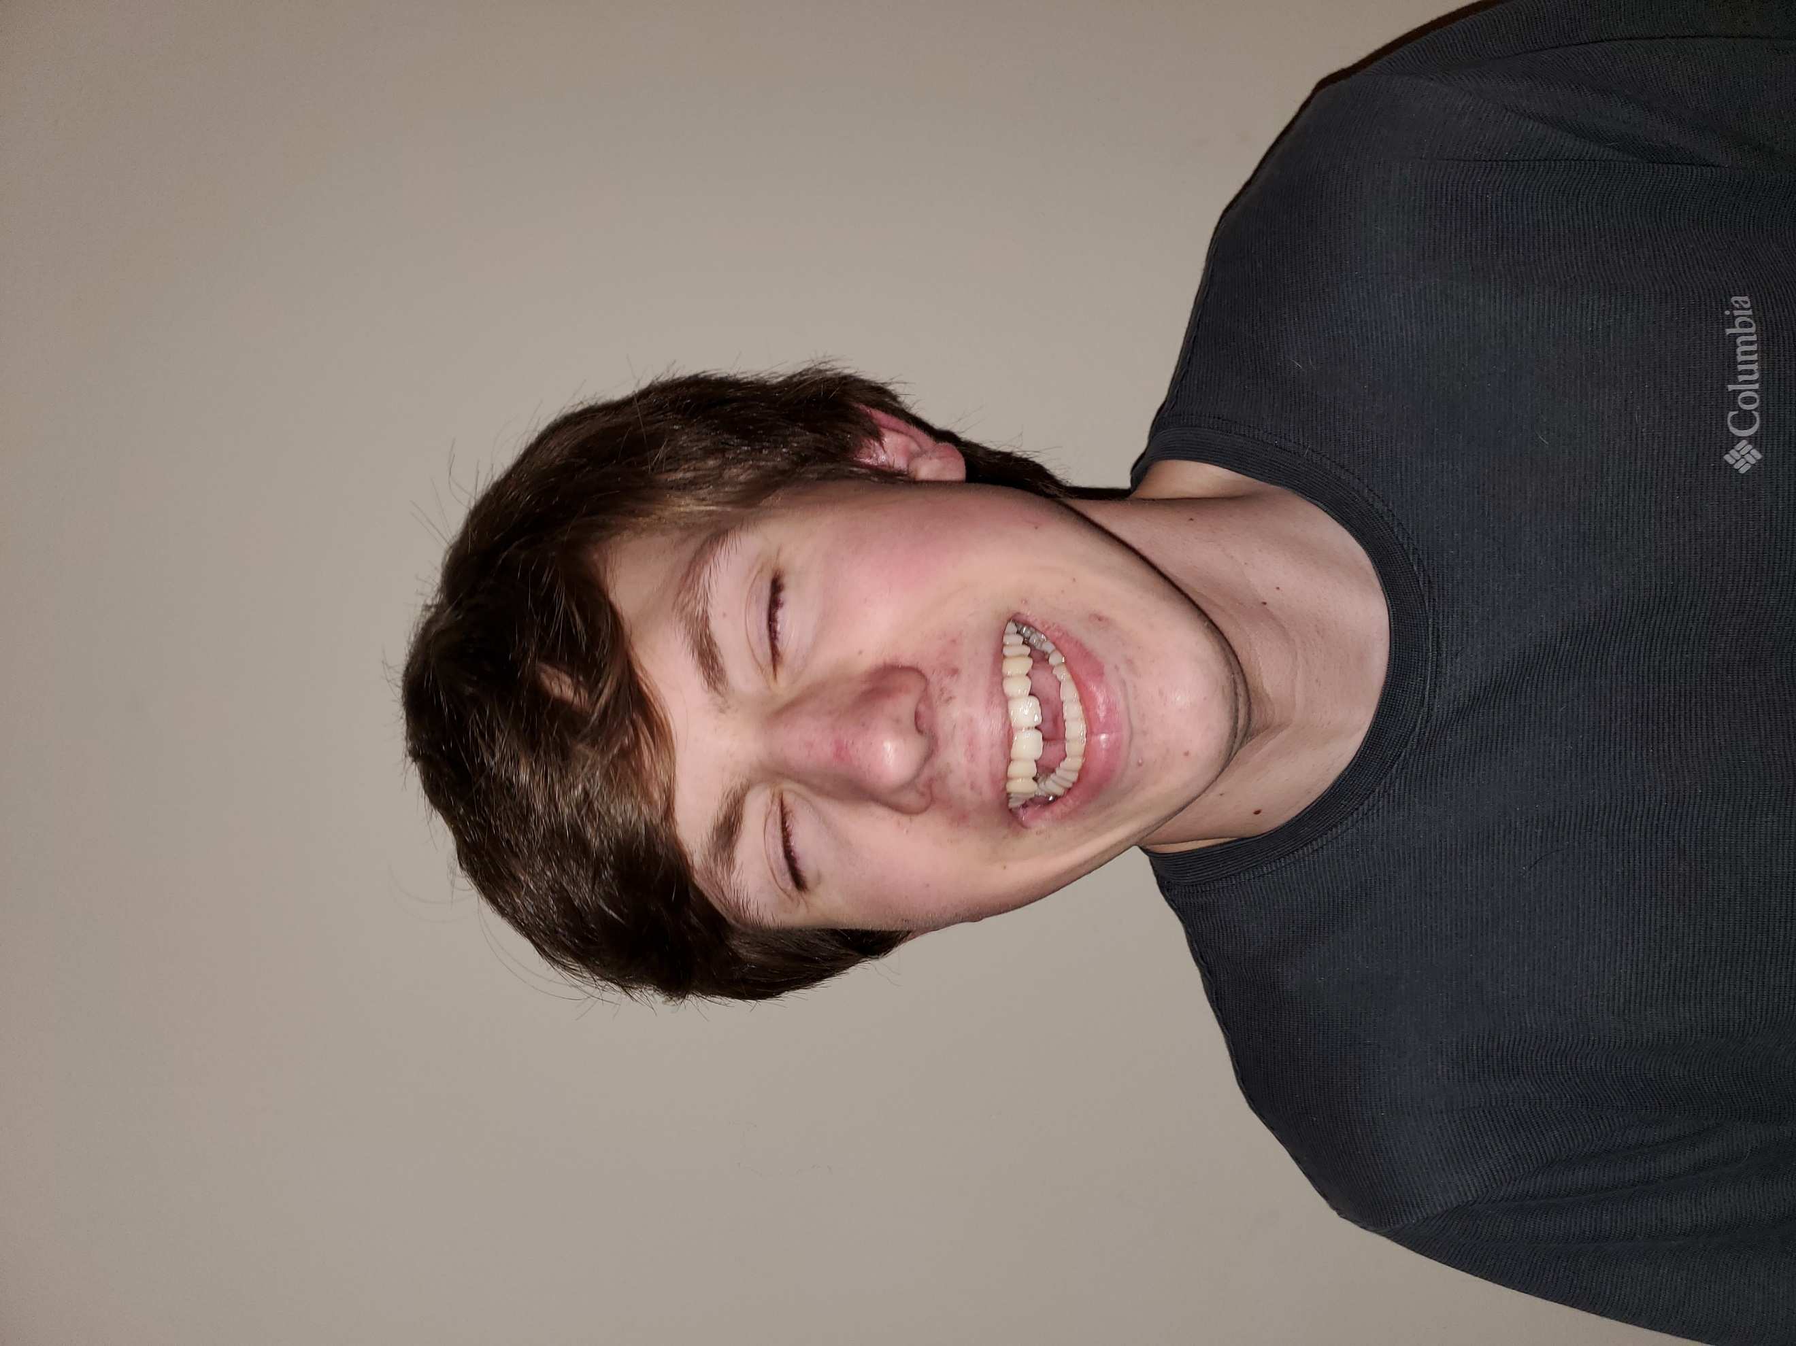Martin lives at home, buses to high school, and is studying for his driver’s learning permit. He has an Xbox, a Nintendo Switch, a Chromebook, and a cell phone with a decent data plan. He does his surfing and schoolwork at his bedroom desk or on his bed and does not consider himself very technical.

Martin enjoys D&D (Dungeons and Dragons), weird history facts off the internet, his high school drama club, and is a local Venturer (scouting). He would like to use Blogger to share ideas on D&D development but is wary of internet trolls and bad discussion comments.

Quote: “I’m not on the internet, I’m watching *Critical Role*!”

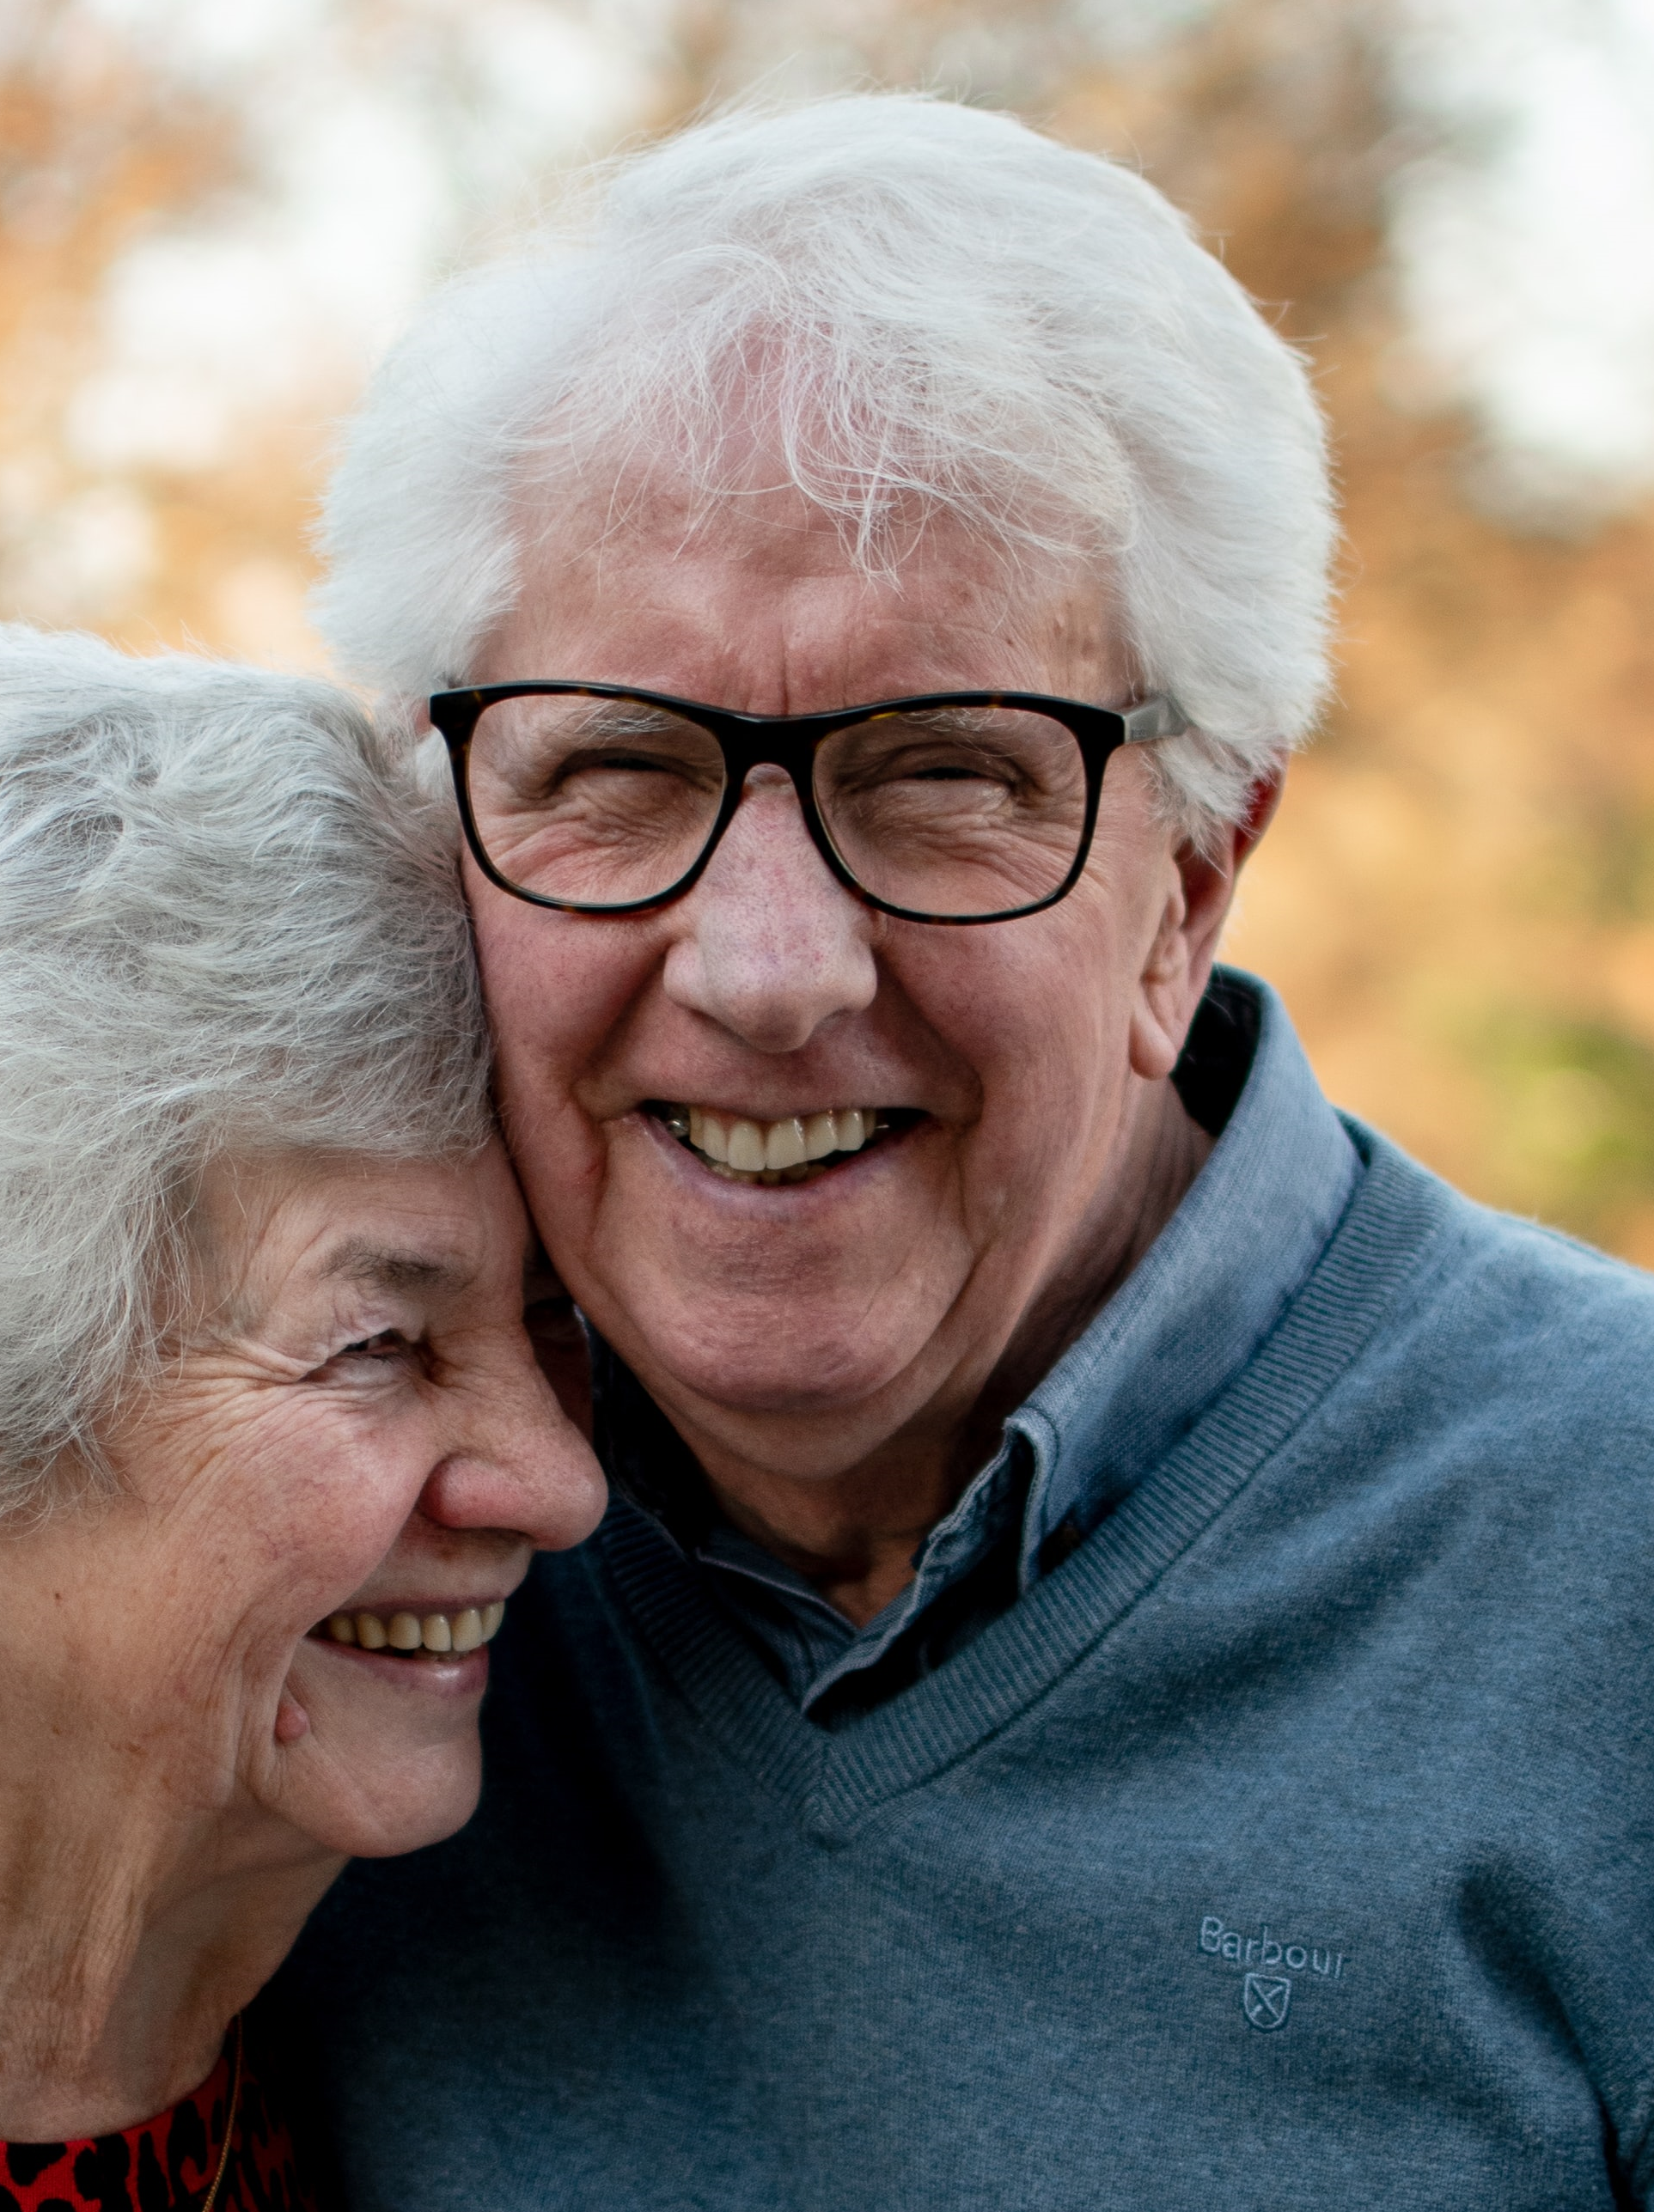

**Nelson Riley**, 78yo (silent)

Nelson Riley lives in a retirement community with his wife. He is a retired grade school math and science teacher who has watched society gradually decline through each and every episode of *The Simpsons*.

Nelson uses his laptop at his desk or kitchen table to check email daily, or to edit memoires and family stories he shares with his brothers. He has considered Blogger as an outlet for his communications and sharing with extended family members.

He does not consider himself experienced on the web, and he doesn’t trust ecommerce with his credit card. He is comfortable with his cell phone for calls and texts and follows a weekly link for webcast church services.

Quote: “Why would you trade up a cell phone, just because it’s eight years old?”

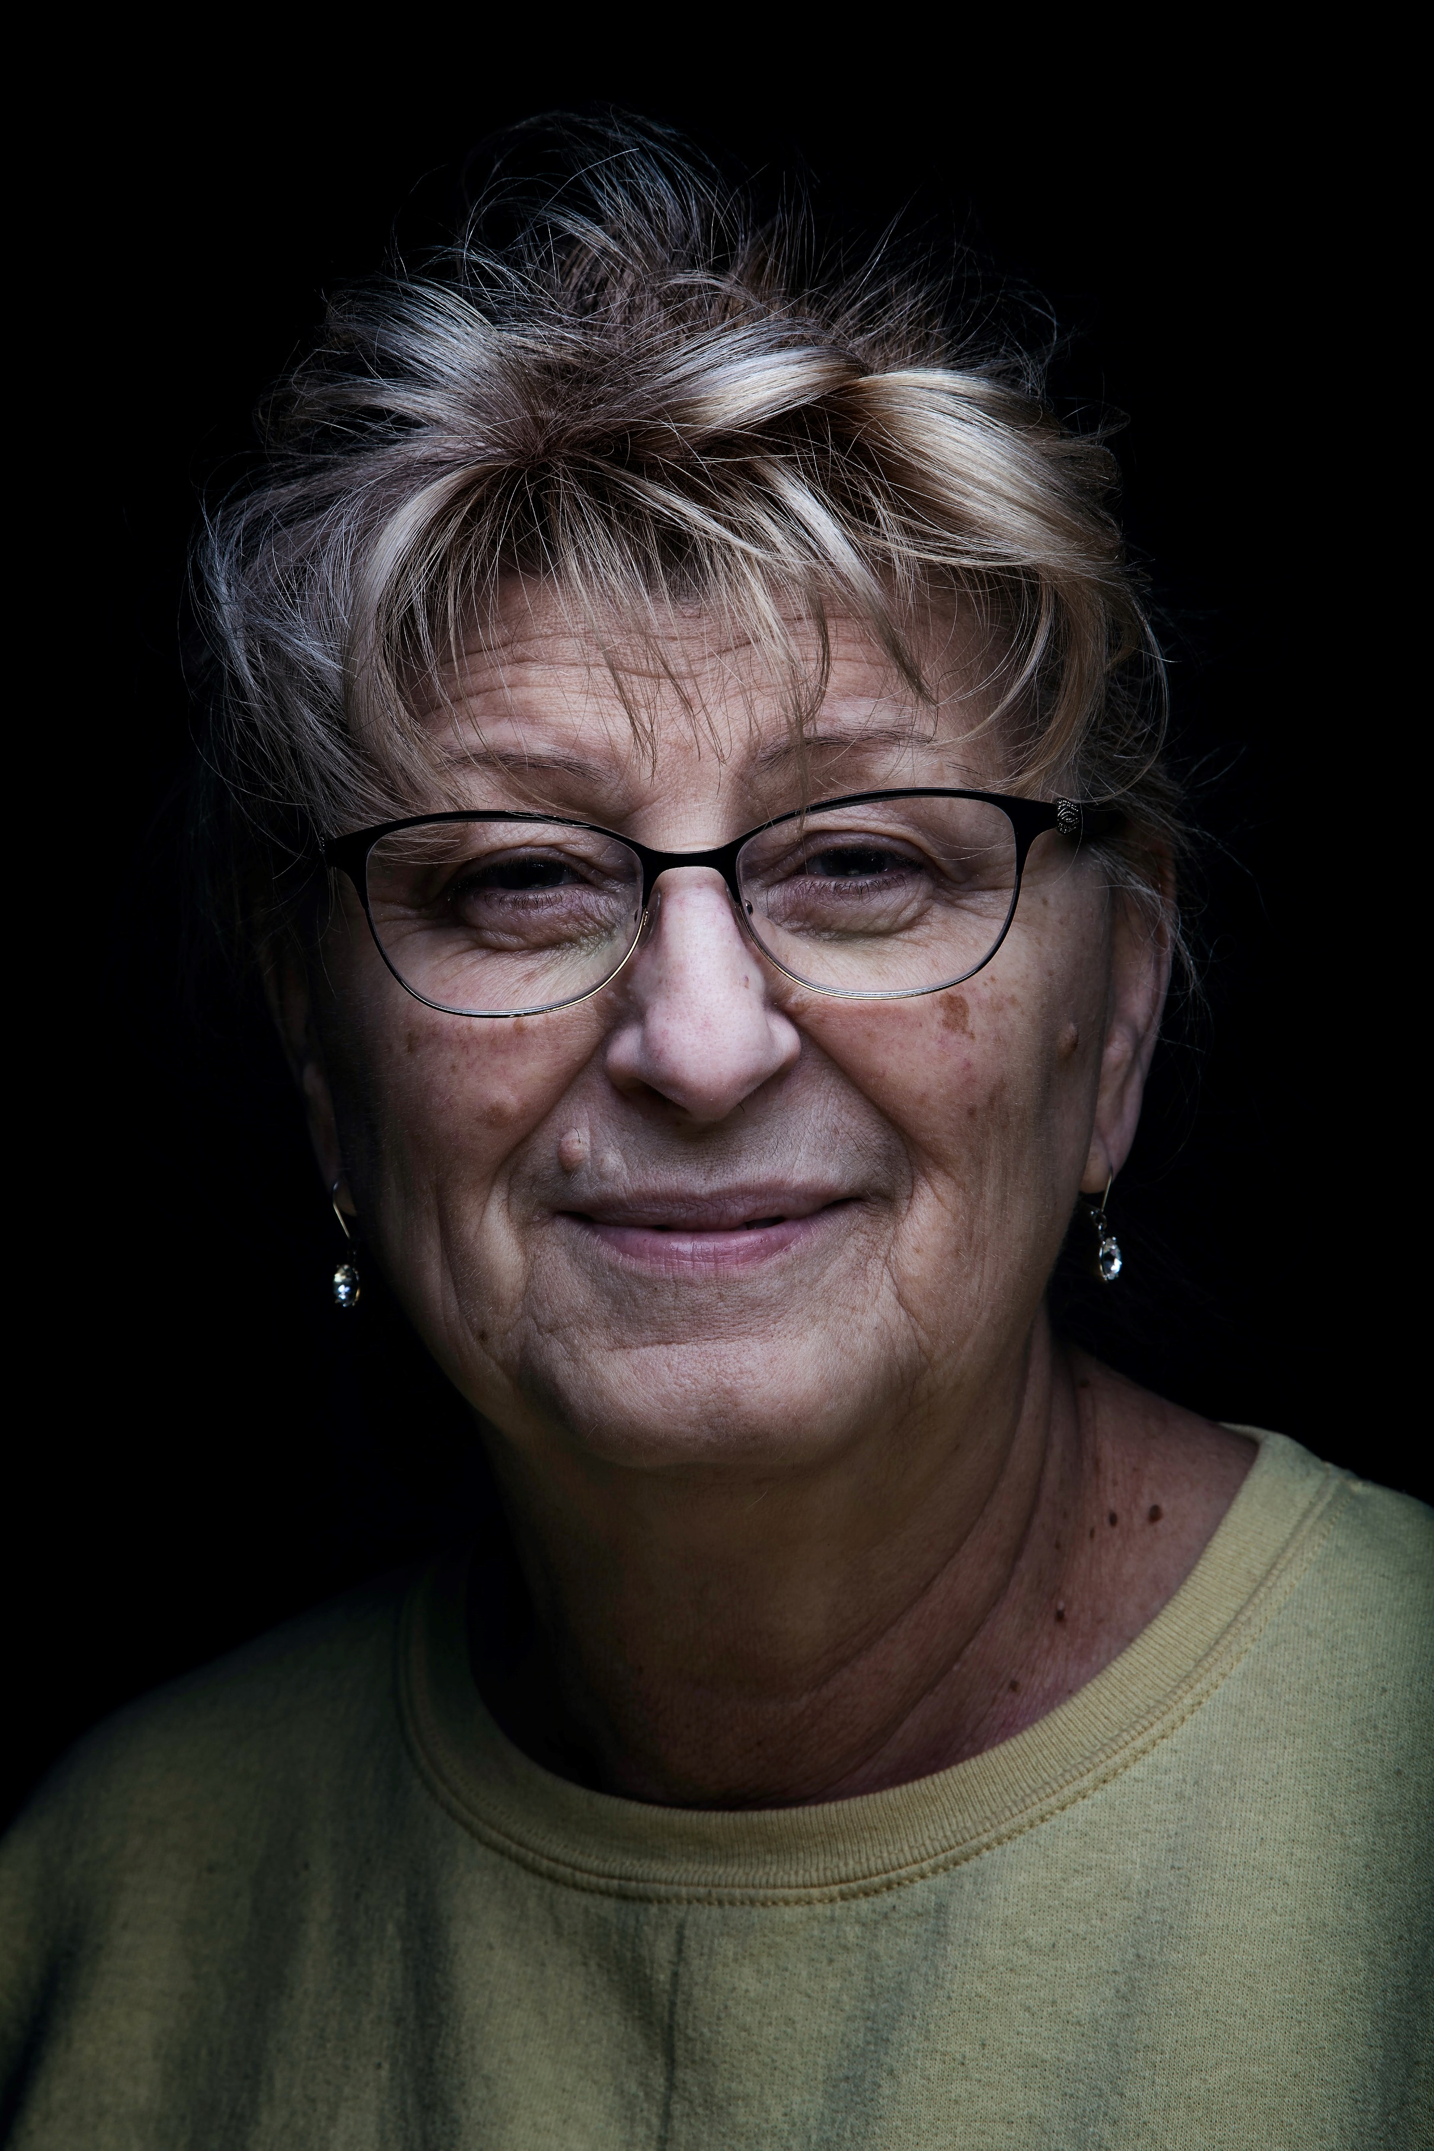**Gwen Beckett**, 68yo (boomer)

Gwen is a retired designer and artist who lives by herself above her garage, renting out the main house to a young family. She participates in a community of artists who get together to sell their work a couple times per year. She is comfortable with technology, and uses email, her cell phone, and texts regularly.

Gwen is currently authoring a novel she plans to self-publish. She has tried blogging a little in the past and may do so again to promote her book. She is certain her blog can help others live a better, simpler life, but wonders how to expand her audience.

Quote: “Simple living is the key to being satisfied with what you have.”

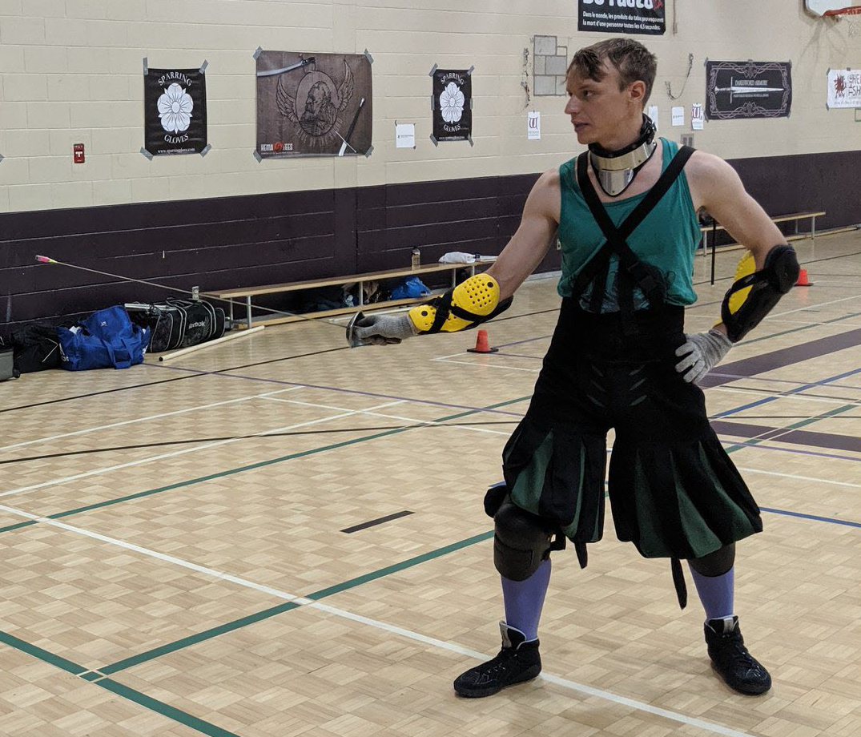

**Henry Huxtable**, 27yo (millennial)

Henry has a degree in biology and is a gardening design specialist. He is comfortable using standard software and social media with his laptop and cell phone.

He regularly participates in sword fighting competitions and provides instruction through a side-business he runs with his fiancée. He is considering a blog to promote his business and to share historically accurate sword fighting equipment and techniques but doesn’t have much time for it.

Quote: “Our main focus is Germanic longsword in the Lichtenauer style and Military sabre from Hutton.”

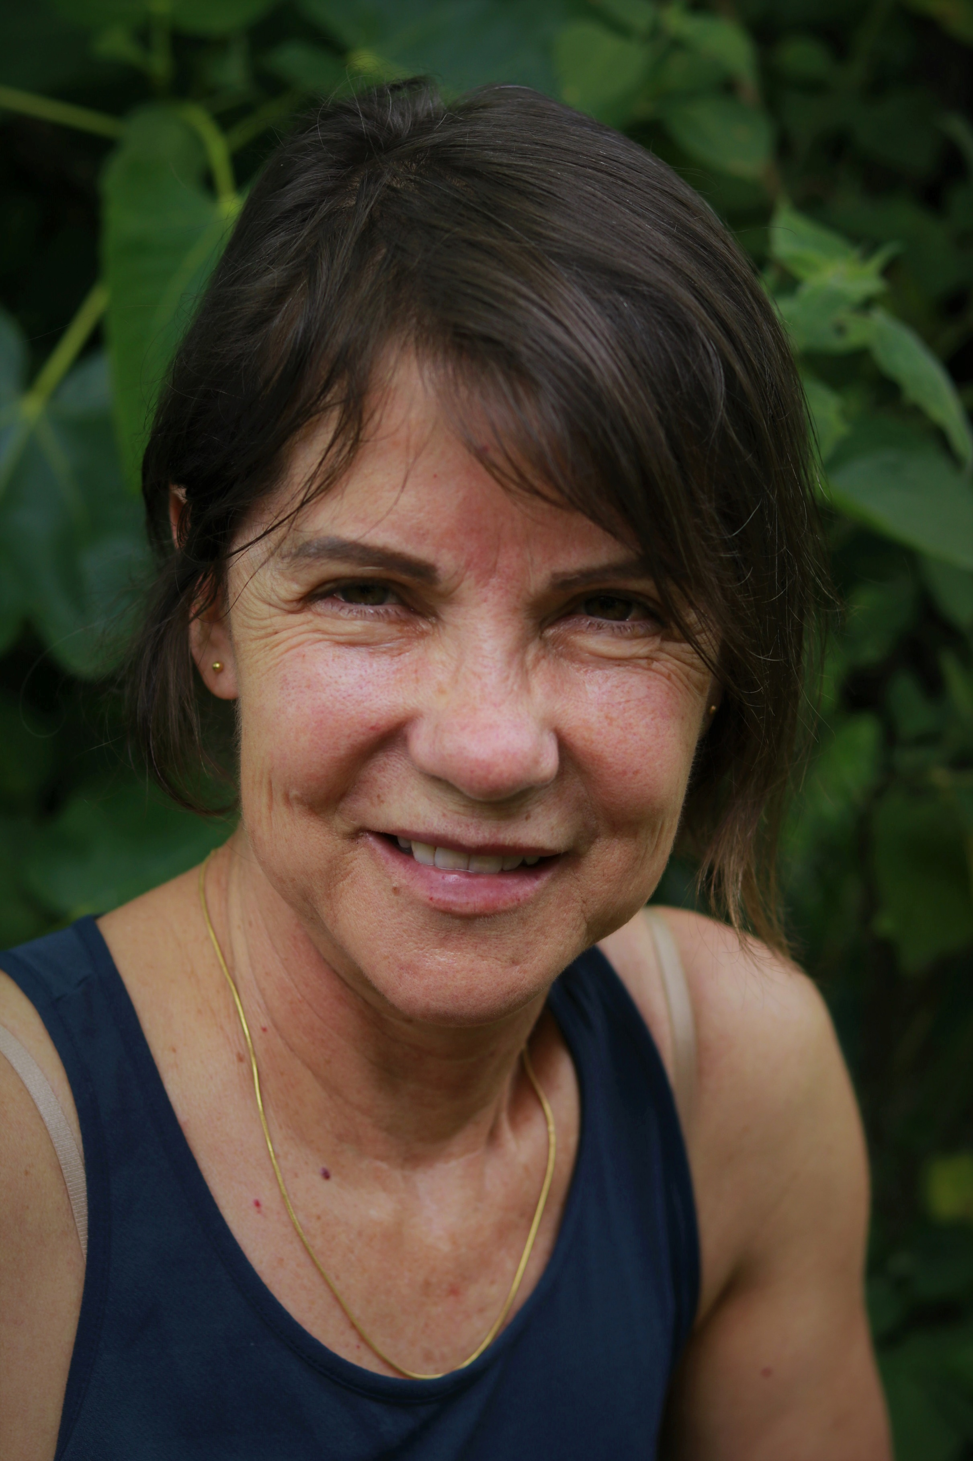

**Maria Kartiva**, 53yo (gen X)

Maria lives with her spouse and high school-aged son. She has a degree in engineering and an MBA and is a marketing director for a non-profit. She supports colleagues who blog and is considering her own work blog to promote Canadian heritage sites and aid the boards who oversee them. She hopes to setup and maintain the site, primarily jurying content contributions from others.

She is extremely comfortable with technology but has little time or patience for tasks that take her away from strategizing. She primarily works remotely from a dedicated home office, though she keeps a desk at work for meetings.

Quote: “If I can quickly set it up and get it to do what I want, great; if not I might as well hire someone else to do it.”

Photo Credits

“**Martin Rutger**”

Raaflaub, R., (2022). “Martin Rutger” [Personal photo].

“**Nelson Riley**”: Photo by [Joe Hepburn](https://unsplash.com/@thatjoebloke?utm_source=unsplash&utm_medium=referral&utm_content=creditCopyText) on [Unsplash](https://unsplash.com/s/photos/senior-white-man?utm_source=unsplash&utm_medium=referral&utm_content=creditCopyText)

Hepburn, J., (n.d.). [man with wife]. [online image]. Unsplash. Retrieved June 19th, 2022 from <https://unsplash.com/photos/qr7rfIthbvc>

“**Gwen Beckett**”: Photo by [Nickolas Nikolic](https://unsplash.com/@nickolasnikolic?utm_source=unsplash&utm_medium=referral&utm_content=creditCopyText) on [Unsplash](https://unsplash.com/s/photos/old-woman?utm_source=unsplash&utm_medium=referral&utm_content=creditCopyText)

Nikolic, N., (n.d.). [headshot of woman]. {online image]. Unsplash. Retrieved June 19th, 2022 from <https://unsplash.com/photos/iwV1-SWB4n8>

“**Henry Huxtable**”

Raaflaub, R., (2021). “Henry Huxtable”. [Personal photo].

“**Maria Kartiva**”: Photo by [Luiza Braun](https://unsplash.com/@luizabraun?utm_source=unsplash&utm_medium=referral&utm_content=creditCopyText) on [Unsplash](https://unsplash.com/t/people?utm_source=unsplash&utm_medium=referral&utm_content=creditCopyText)

Braun, L.. (n.d.). [headshot of woman]. [online image]. Unsplash. Retrieved June 19th, 2022 from <https://unsplash.com/photos/xbAXuNLzrkQ?utm_source=unsplash&utm_medium=referral&utm_content=creditShareLink>